|  |  |
| --- | --- |
| Team ID | PNT2022TMID16931 |
| Project Name | Project – News Tracker Application |
| Maximum Marks | 8 Marks |

**SETTING UP APPLICATION ENVIRONMENT**

**CREATE IBM CLOUD ACCOUNT**

**STEP 1 : ibm.com/academic/home and do register and sign in**

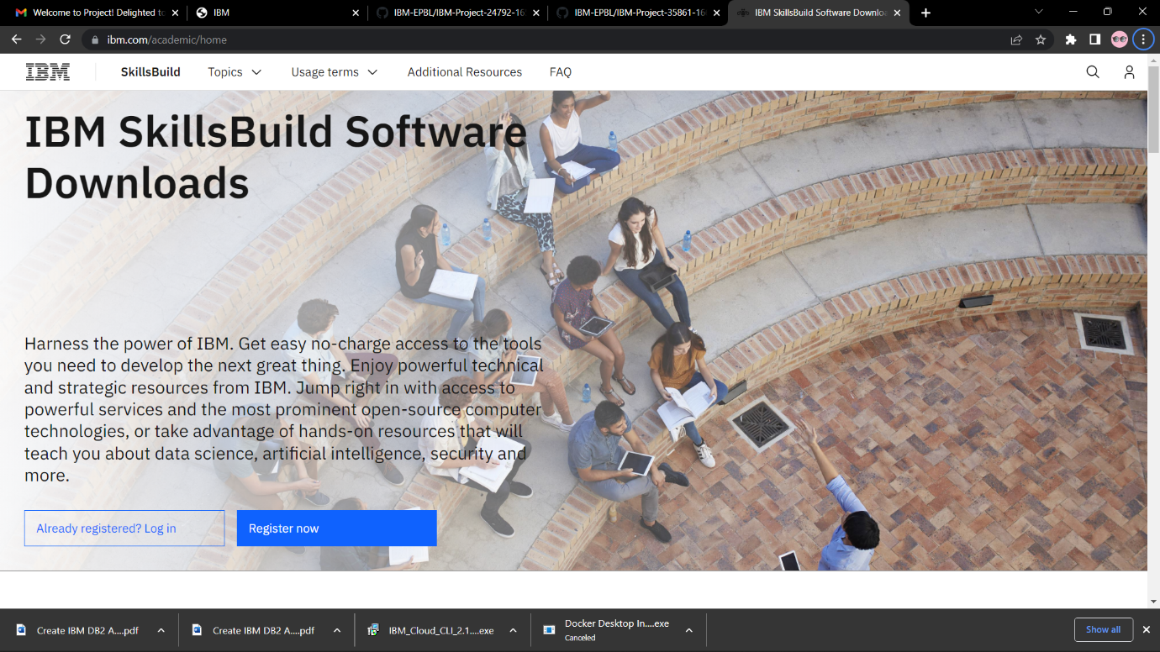

Here I have already registered so I click on login to get into the cloud account.

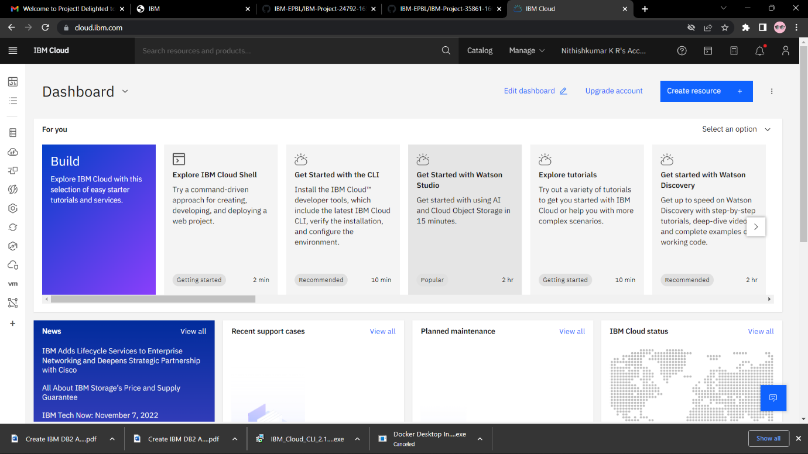

**Cloud account created successfully.**